1.

A **Boolean** value is either true or false, the two Boolean values are **True** and **False** (in python)

2 != 3 (true)

1 > 3 (false)

7 == (5+2) (true)

2.

A **flowchart** is a type of diagram that represents an algorithm, workflow or process. The flowchart shows the steps as boxes of various kinds, anh their order by connecting the boxes with arrows. This diagrammatic reprensentation illustrates a solution model to a given problem. **Flowcharts** are used in analyzing, designing, documenting or managing a process or program in various fields.

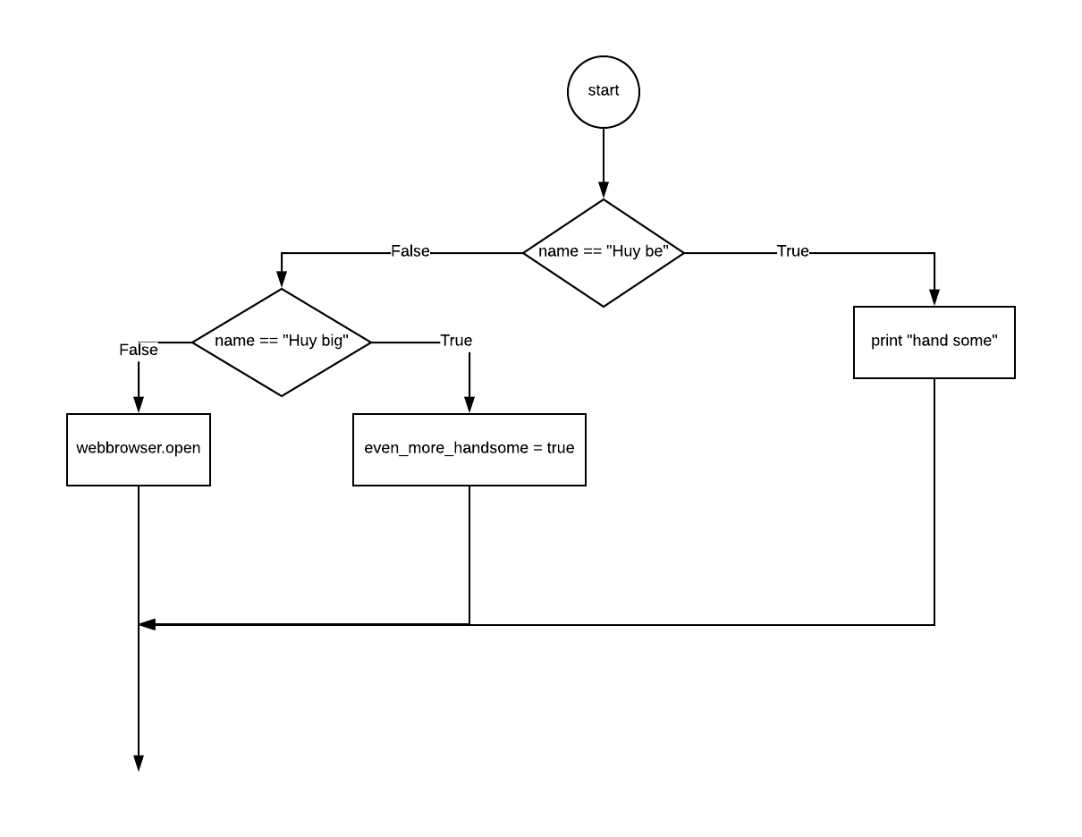

3.

-Nested conditional is a conditional inside a branch of another conditional.

-Example:

a = int(input(“nhap a:”)

If a % 2 = 0:

Print(“ a chia het cho 2”)

Else:

Print(“a khong chia het cho 2)